**IB Physics 1 Fall Semester Final Review Worksheet**

**The Final Exam will be an IB Physics Exam Format with 30 multiple choice questions similar to those on Paper 1 and 30 pts worth of extended multipart questions similar to the kind on Paper 2 and Paper 3. Only content related to topics that we have covered thus far will be included.**

**Your raw scores will be curved and adjusted to a grade distribution. It will count for approximately 15% of your semester grade. You will be provided with a Data Packet.**

**Topic 1.1 – Measurements in physics**

1. Find the difference in order of magnitude for the following comparison: The size of the atom to the size of the quark. **105**

2. Find the order of magnitude for the following calculation: The time it takes light to transverse a nucleus. **3 x 10-24 s**

3. Which row lists from left to right a derived unit and a fundamental unit? **none**

a. Newton, Coulomb c. Candela, Mole

b. Ampere, Newton d. Kelvin, Joule

4. Which equation must be wrong? Note that *t* is in s, *v* is in ms-1, *a* is in ms-2, *x* is in m, *F* is in kgms-2 and *m* is in kg.

a. *v*2 = 2*ax* c. *v* = *x/t*

b. *x* = *vt* + (1/2)*at*2 **d.** *F* = *m/a*

5. Convert 54 mi s h-1 to feet. Be sure to show each well-chosen one. **79.2 ft (use dimensionalysis)**

6. Estimate how many kilograms are in a 150-pound man. Est: **70 kg 3 sigfig: 71.4 kg**

7. Using the technique of the well-chosen one, convert the quantity 125 mJ into its equivalent in kJ.

**1.25 x 10-4 kJ**

8. Recall that normalized scientific notation requires the expression of a number as a power of 10 multiplied by a factor between 1 and 10. Thus 1.2×103 is 1200, and 12×102 is also 1200, but 1.2×103 is in normalized scientific notation whereas 12×102is not. Express 61200 in normalized scientific notation. **6.12 x 104**

9. Express .00004203 in normalized scientific notation. **4.203 x 10-5**

10. Estimate the amount of time it takes light to travel from your television set to your eye.

**10 ns**

11. Estimate how many paper clips you would need to equal the weight of a 16-pound bowling ball.  **104**

12. Find the line’s length to the maximum number of significant figures allowed by the centimeter ruler.

**7.12 cm or 7.14 cm**

13. Determine the number of significant figures in each of the following.

(a) 0.23 **2** (b) 1.23 **3** (c) 1.203 **4** (d) 1.230 **4**

(e) 0.002 **1** (f) 1.002 **4** (g) 1.0020 **5** (h) 12×10-2 **2**

(i) π (j) 0.00010000 **5** (k) 5.98×1024 **3** (l) 1.60×10-19 **3**

14. Compute the following quantities to the correct number of significant figures.

(a) 2.3 × 2.55 (b) 2.30 × 2.55 (c) 1.2×10-2 + 7.8 (d) 1.2×10-2 + 7.80

(e) 1.2×10-2 + 7.800 (f) 2.3 ÷ 2.55 (g) 1.2×10-2 + π (h) 1.20×10-2 ÷ 7.80

**a) 5.9 b) 5.87 c) 7.8 d) 7.81 e) 7.812 f) 0.90 g) 3.154 h) 0.00154**

**Topic 1.2 – Uncertainties and errors**

15. What is the measured length of this line in mm? Use the amount of significant figures a wooden meter stick is capable of supplying. **9.2 mm**

0 cm 1 cm

16. What is the precision of this measurement? **0.1 mm (default)**

17. If the above line is one side of a perfect square, what is the area of that square, taking into account the correct number of significant figures and the correct units? Note that area is length times width, and the length equals the width in a square. **85 2 mm2**

18. What is the raw uncertainty in your answer from problem (15)? **0.1 mm (Taken from the precision of the ruler) Note: raw uncertainty and absolute uncertainty are the same thing.**

19. A student measures a line to be 4.5 cm ± 0.1 cm. Find the absolute uncertainty in the measurement. **0.1 cm**

20. Find the raw uncertainty in the measurement. **0.1 cm**

21. Find the fractional uncertainty in her measurement. **0.0222**

22. Find the percentage uncertainty in her measurement. **2.22%**

23. A flagpole is placed on the roof of a house. A student measures a flagpole to be 2.75 m ± 0.15 m. The same student measures the height from the ground to the base of the flagpole to be 3.8 m ± 0.4 m. If the flagpole is mounted vertically upward (straight up), how far is the tip of the flagpole above the ground. Be sure to use significant figures and include a raw uncertainty with your answer. **6.6 0.6 m**

24. A car travels 350 m ± 25 m in 16.5 s ± 0.4 s. Calculate its speed. Be sure to use significant figures and include a raw uncertainty with your answer. **21 2 m/s**

|  |  |  |  |  |
| --- | --- | --- | --- | --- |
| Height  *H* / m  Δ*H* = ±0.1 m | Fall Time  *T*i / s  Δ*T*i = ±0.3 s | | | Average Fall  Time  *T* / s  Δ*T*i = **\_\_0.3 s** |
| Trial 1 | Trial 2 | Trial 3 |
| 1.4 | 1.5 | 1.8 | 1.6 | **1.6** |
| 1.7 | 1.9 | 2.1 | 2.3 | **2.1** |
| 2.0 | 2.4 | 2.9 | 2.8 | **2.7** |
| 2.5 | 3.5 | 3.7 | 3.6 | **3.6** |

25. Complete the table that shows data gathered by an IB student during an experiment in which a parachute was dropped from different heights.

26. Does it appear that the student has done the right number of trials and variations to satisfy the internal assessment requirements of the IBO? Be sure to explain very clearly your reasoning.

27. On a graph of your own making, plot *Height* vs. *Average Fall Time*. Be sure to label the graph properly.

**Note: Independent Variable for this Expt was H and the Dependent Variable was T. Graphs should be DV vs IV not IV vs DV as instructed here. Vs. always means y vs x so these answers are for the proper processing, not the actual question here. Remember, graphing always includes some error so your answers may vary a bit.**

28. On the same graph sketch the correctly-sized vertical error bars on each point.

29. On the same graph sketch in your line of best fit. Calculate its slope. **1.8452**

30. On the same graph sketch in the maximum and minimum slopes, using the first and last error bars as your guide. Calculate their slopes. **1.0769 and 2.8889**

31. Calculate the uncertainty of the slope. **m = 1.8 0.9 s/m**

32. What are the x-intercepts of the lines representing the minimum and maximum slopes? **0.5000 and -3.0333**

33. Calculate the uncertainty of the x-intercept. **b = -1 2 s**

**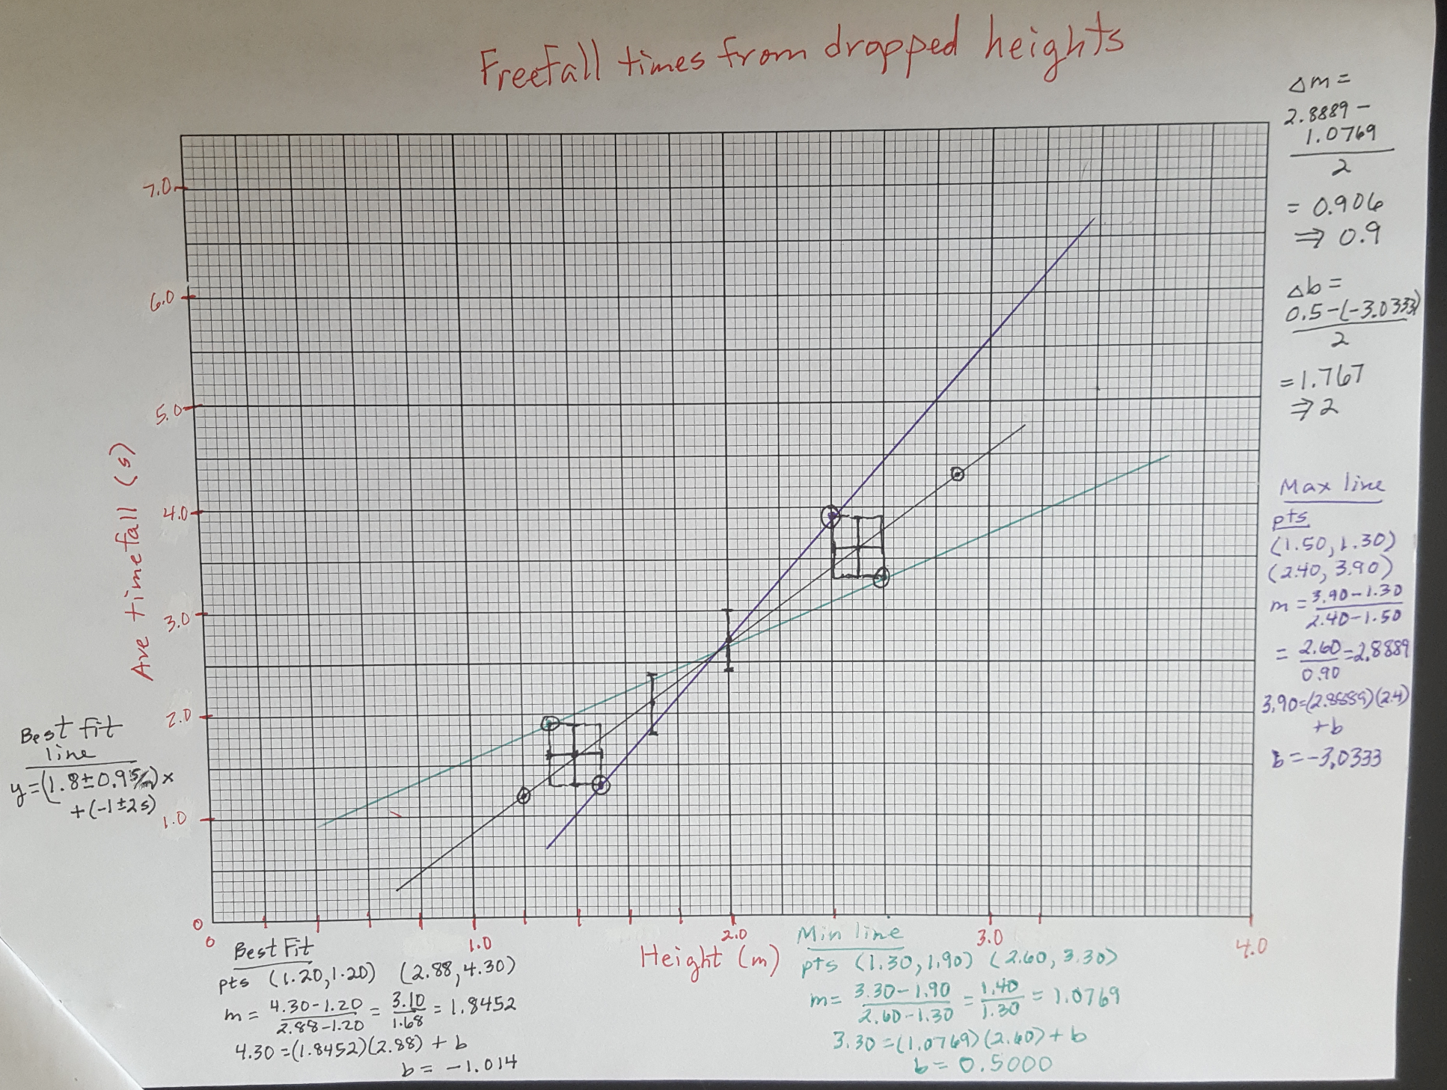**

**Topic 1.3 – Vectors and scalars**

34. Explain clearly the difference between a scalar and a vector. **Scalar has magnitude only.** **Vector has magnitude and direction.**

35. Give three examples of scalars.  **Energy, mass, time, work, position, distance, speed, etc…**

36. Give three examples of vectors. **Velocity, force, momentum, acceleration, displacement, etc…**

37. Two vectors **A** and **B** are drawn to scale below. In each box below make a precise sketch of the required sum or difference. Be sure to label each of your vectors.

**A**

**A** - **B**

**A**

**B**

**A** + **B**

**B**

**B**

**A** - **B**

**A** + **B**

**B**

38. A vector **A** is shown drawn to scale below. In each box below make a precise sketch of the required product or quotient.

**A**

**A**/2

2**A**

39. A car travels at 50. kmh-1 up a ramp making an angle of 30° with the horizontal. Find its horizontal component. Include a sketch. **43.3 km/h**

40. A car travels at 50. kmh-1 up a ramp making an angle of 30° with the horizontal. Find its vertical component. Include a sketch. **25 km/h**

41. A velocity vector has a horizontal component of 45 ms-1 and a vertical component of 75 ms-1. Find the magnitude of the velocity vector. Include a sketch. **87.5 m/s**

42. A velocity vector has a horizontal component of 45 ms-1 and a vertical component of 75 ms-1. Find the direction of the velocity vector. Include a sketch. **59**

43. The vertical component of a velocity vector points up and has a magnitude of 20. ms-1. The velocity vector itself makes an angle of 25° with the horizontal. Find the magnitude of the velocity vector. Include a sketch. **47.3 m/s**

44. The vertical component of a velocity vector points up and has a magnitude of 20. ms-1. The velocity vector itself makes an angle of 25° with the horizontal. Find the magnitude of the horizontal component of the velocity vector. Include a sketch.

**42.9 m/s**

**Topic 2.1 – Motion**

1. A fly travels along the *x*-axis. His starting point is *x* = 16 m and his ending point is *x* = -25 m. His flight lasts 4.0 seconds. How far has he flown, what is his displacement, what is his speed, and what is his velocity? **41 m, - 41 m , 10 m/s, - 10 m/s**

2. A car traveling at 22 ms-1 is brought to a stop in 4.5 seconds. What is its acceleration? **4.9 m/s2**

3. The acceleration of a car is – 1.5 ms-2. If its initial velocity is 8.0 ms-1, what is its velocity 3.0 seconds later? **3.5 m/s**

*At t = 0.00 s a fly is located at 0.0 m (marked with an* × *). The fly is traveling in the positive x-direction. Every 0.25 seconds there is another* × *marking the fly’s position.*

0

5

10

15

20

meters



*t*(s)

*x*(m)

∆*t*

∆*x*

*v*

4. Complete the table:

|  |  |  |  |  |
| --- | --- | --- | --- | --- |
| 0 | 0 | 0 | 0 | 0 |
| 0.25 | 2 | 0.25 | 2 | 8 |
| 0.50 | 6 | 0.25 | 4 | 16 |
| 0.75 | 12 | 0.25 | 6 | 24 |
| 1.00 | 20 | 0.25 | 8 | 32 |

5. On a graph, plot the *velocities* vs. the *times* from your table. Then find the acceleration of the fly.

**a = 32 m/s2**

*Pinky and The Brain have developed a rocket that will accelerate at 21.0 ms-2.*

6. How fast will they be going 15.0 seconds after liftoff? **315 m/s**

7. How far will they have gone 15.0 seconds after liftoff? **2360 m**

*A bowling ball is launched upward with an initial speed of 15.0 ms-1.*

8. How long will it take to reach its maximum height? **1.53 s**

9. How far above its launch point will it go up? **11.5 m**

10. How long will it be in the air before returning to its launch point?  **3.06 s**

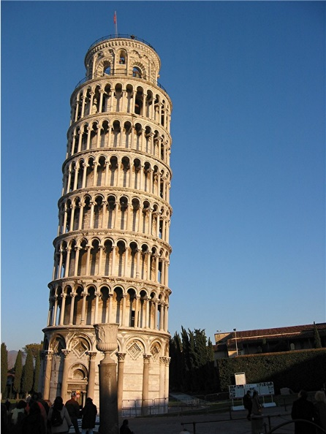*A bowling ball is dropped from a balcony on the Tower of Pisa that is 45 m above the ground.*

11. How long will it take to reach the ground? **3.03 s**

12. What will its speed be when it reaches the ground? **- 29.7 m/s**

*A bowling ball is thrown downward at 15 ms-1 from a balcony on the Tower of Pisa that is 45 m above the ground.*

13. What will its speed be when it reaches the ground? **-33.3 m/s**

an00765_[1]

14. How long will it take to reach the ground? **1.86 s**

*A whale is in free-fall. Her speed vs. time is plotted in the graph.*

15. Draw labeled free-body diagrams of the whale at the times *t* = 0 s, *t* = 20 s, and *t* = 50 s.

FL

FL

*v* / ms-1

0

15

30

*t* /s

0

10

20

30

40

mg

mg

mg

16. What is her terminal speed? **27 m/s**

17. What is her instantaneous acceleration at *t* = 10 s?  **1 m/s2**

18. Explain how you would find the total displacement of the whale during her first 30 seconds of freefall from the above graph. Then estimate it. **Area under the curve. About 1000 m.**

19. What does the slope of a velocity vs. time graph tell you? **Instantaneous acceleration**

20. What does the area under an acceleration vs. time graph tell you? **change in velocity**

*Two cars A and B are driving at velocities represented below as scale arrows.*

**v**B

**v**A

21. Sketch accurately the vector representing the velocity of A relative to B on the grid provided. Make it the same scale. **VAB = VA – VB**

22. If the grid lines in the previous graph represent 1 ms-1 increments, find the magnitude of the vector you drew representing the velocity of A relative to B. Be very exact!  **(VAB x = 9 blocks, VAB y  = 10 blocks) 13.5 m/s**

**Topic 2.2 – Forces**

R

mg

23. What is the weight of an 85-kg person? Draw a free body diagram of that person standing on the ground. Be sure to include labels on all of the forces you have included.

R

mg

T

fd

24. A wooden crate is being dragged along a floor to the right with a tension of 60 n being applied at an angle of 40° above the horizontal. There is friction between the crate and the floor. Draw a labeled free body diagram of the crate.

25. If the crate of the previous problem is not accelerating, what is the value of the friction force?  **46 N**

26. List the contact force(s) we have discussed. List the action-at-a-distance force(s) we have discussed.

**Contact forces: Tension, Normal, Friction, General FA , Lift, drag, buoyancy etc…**

**Distance forces: Weight/gravity, Electric force, Magnetic force**

*A 75-kg mass is supported by three cables as shown. The two cables anchored to the ceiling make an angle of 45° with the ceiling. The three tensions are labeled.*

45°

45°

*knot*

**T**1

**T**2

**T**3

27. Find the numeric value of *T*3. **736 N**

28. Find the numeric values of *T*1 and *T*2. **Both are 520 N**

R

mg

F

fd

29. A 15-kg crate being pulled leftward by a force of 25 N, has a dynamic friction force of 18 N. Make a free-body diagram of the crate which includes all forces acting on it. Then find the acceleration of the crate.  **– 0.47 m/s2**

30. What is the acceleration of a 680-newton person who is experiencing a net force of 300 n? **4.33 m/s2**

*There are exactly two forces acting on the 25-kg crate, as shown.*

30°

400 n

200 n

31. What is the resultant force acting on it? **529 N at 49.1**

32. What is the acceleration of the crate? **21.2 m/s2 at 49.1**

*[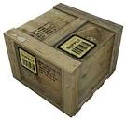](https://www.google.com/url?q=http://half-life.wikia.com/wiki/Supply_Crate&sa=U&ei=s1B-U40Kho7IBP2FgvAB&ved=0CC4Q9QEwAA&sig2=f3GrBBxz9HcVZFQ3xW28jw&usg=AFQjCNGMPT0jQrzxTTKAFUw2bSGNpL8UXw)A 25-N crate is given an initial velocity of 8.0 ms-1 on a floor. It slides 12 m.*

33. Find the constant acceleration of the crate, the friction force that stops the crate, and the coefficient of dynamic friction between the crate and the floor.

**6.8 N**

34. Explain why it initially takes a greater force to make a crate slide than it does to keep that crate sliding once it has begun.

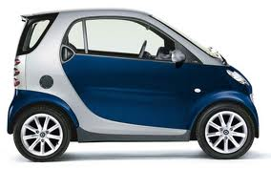 **Because s >d**

35. Explain the concept of antilock brakes, and why they stop a car in a shorter distance than brakes that completely lock the wheels so that the car skids (the rubber of the wheels slides on the pavement, rather than rolls). **Antilock brakes prevent skidding or slipping and allows maximum contact of the tire to road with pure rolling, thus maximizing friction and the ability to brake.**

36. Consider the two crates resting on the floor. Draw a free-body diagram for each of the crates. Label the forces. Then consider all of the forces you labeled. Which pairs, if any, are action-reaction pairs?

M2

M1

M1

R1

MT

M2

R2

R1

F21

MTg

M2g

M1g

**F21 and R2 are an action reaction pair.**

**Topic 2.3 – Work, energy and power**

37. An 820-kg Smart Car has an acceleration of 1.5 ms-2. What is the work done by the net force acting on the car if it travels 125 meters? **154 kJ**

30°

38. What is the work done by the 300.-N tension shown if it is used to drag the 250-N crate 45 m across the floor at a constant speed? **11.7 kJ**

*F* / N

0

10

*x* / m

0.0

1.0

2.0

3.0

39. What is the work done by the variable force whose graph is shown from *x* = 1.0 to *x* = 3.0 m?

**8 J**

*The Smart Car shown in the picture has speed and mass as shown.*



*v* = 20. ms-1

850 kg

40. What is the kinetic energy of the car at this moment? **170 kJ**

41. If the driver suddenly applies the brakes and brings the car to a stop in 4.0 s, what is the work done by the friction force between the tires and the road surface? **– 170 kJ**

42. What is the average friction force during the braking action? **4250 N**

43. Suppose the car drives up a hill whose altitude is 45 m above the car’s starting point. What is the change in potential energy of the car in going up the hill from its starting point?  **375 kJ**

44. If the car in the previous problem begins to slide down the ice-covered and (magically) frictionless hill, what will its speed be when it is at an altitude of 25 m? **19.8 m/s**

45. What will its speed be when it reaches the bottom of the hill? **29.7 m/s**

*A Smart Car accelerates from rest as shown.*



*a* = 3.0 ms-2

820 kg

46. If the constant acceleration occurs over a distance of 50. m, what is the work done by the car in accelerating itself? **123 kJ**

47. How long does the acceleration take? **5.77 s**

48. What, then, is the output power produced by the engine during the acceleration? **21.3 kW**